*USA Crime Analysis*

Question 1:

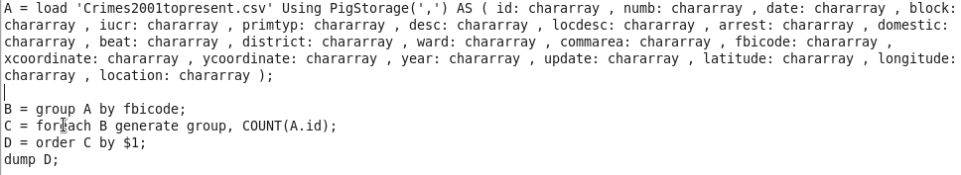

Output:

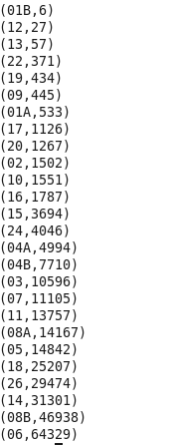

Question 2:

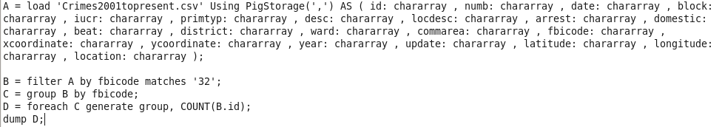

Output:



Question 3:

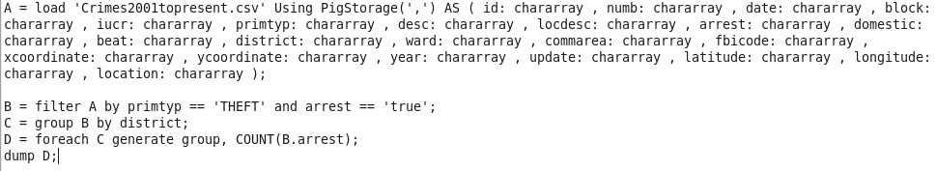

Output:

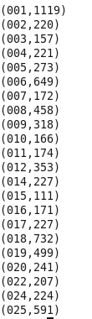

Question 4:

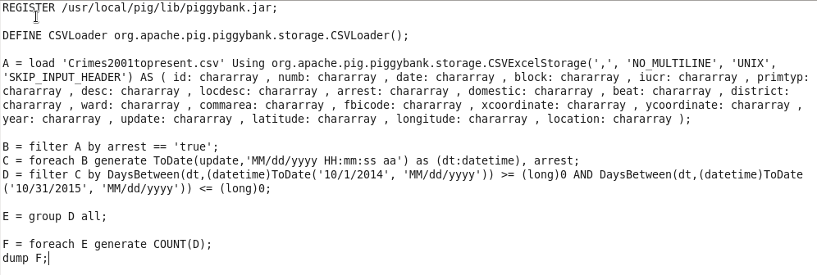

Output:

